**nature physics**

## **Article**

<https://doi.org/10.1038/s41567-022-01902-7>

Josephson–Coulomb drag effect between graphene and a LaAlO3/SrTiO3 superconductor

Received: 25 January 2022

Accepted: 30 November 2022

Published online: xx xx xxxx





Check for updates

**Ran Tao1,2,3,5, Lin Li 1,2,3,5 , Hong-Yi Xie4 , Xiaodong Fan 1,2,3, Linhai Guo1,2,3, Lijun Zhu1,2,3, Yuedong Yan1,2,3, Zhenyu Zhang 2,3 & Changgan Zeng 1,2,3**

## Coulomb drag refers to the phenomenon in which a charge current in one electronic circuit induces a responsive current in a neighbouring

circuit solely through Coulomb interactions. For conventional interactions between electrons, the induced drag current in the passive layer is orders of magnitude weaker than the active current due to the strong dielectric screening effect between them. Here we show a Coulomb drag effect between an active normal conductor and a passive superconductor of Josephson junction arrays, where the passive current is of the same order as the active one. The drag force originates from the interactions between the substantially enhanced dynamical quantum fluctuations of the supercond­ ucting phases in the passive layer and normal electrons in the active layer. We demonstrate this effect in devices composed of monolayer graphene and LaAlO3/SrTiO3 heterointerface. The estimated passive­to­active ratio can reach about 0.3 at the optimal gate voltage and the temperature dependence follows that of the typical Josephson energy between superco nducting puddles. From an engineering perspective, our device may work as a current or voltage transformer, and the drag mechanism lays

## the foundation for synchronizing Josephson­junction­array­based terahertz radiators.

Drag experiments in low­dimensional systems have been instru­ mental in uncovering electron many­body effects as diverse as friction between isolated two­dimensional (2D) electron gases1–3, Luttinger­liquid and Wigner­crystal states in quantum wires4,5, and interlayer phase coherence like excitonic superfluidity6–10, among oth­ ers. The passive­to­active ratio (PAR) offers a dimensionless parameter measuring the drag effects, but its magnitude is normally far below unity1–3. Equal­amplitude active and passive currents may be achieved only when strong intercircuit correlations occur, such as the formation

of exciton­like states6–10. Moreover, the sign of the PAR can be exploited to distinguish various phases and interaction mechanisms4,5,11,12.

Replacing one or both of the conducting layers with supercon­ ducting (SC) material opens opportunities for examining supercon­ ductivity and fluctuation effects13–22. In particular, it was proposed that Coulomb interactions between two SC layers may give rise to the non­dissipative supercurrent drag effect16, which was originally predicted to exist in 3He–4He mixtures23 and neutron stars24. This drag effect was argued to persist even if the active layer is replaced with a

1CAS Key Laboratory of Strongly-Coupled Quantum Matter Physics, and Department of Physics, University of Science and Technology of China, Hefei, China. 2International Center for Quantum Design of Functional Materials (ICQD), Hefei National Research Center for Physical Sciences at the Microscale, University of Science and Technology of China, Hefei, China. 3Hefei National Laboratory, University of Science and Technology of China, Hefei, China.

4Division of Quantum State of Matter, Beijing Academy of Quantum Information Sciences, Beijing, China. 5These authors contributed equally: Ran Tao, Lin Li. e-mail: [lilin@ustc.edu.cn](mailto:lilin@ustc.edu.cn); [xiehy@baqis.ac.cn](mailto:xiehy@baqis.ac.cn); [cgzeng@ustc.edu.cn](mailto:cgzeng@ustc.edu.cn)

### a

*V*int *V*BG

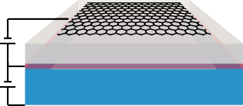

LAO STO

### d

3

2

*R*LAO/STO (k▲)

1

Graphene

**b**

### f

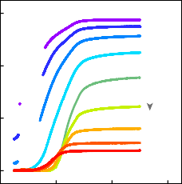

–200 V

*V*BG

200 V

0.4

0.3

**c** 12

10

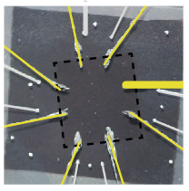

LAO/STO

Graphene

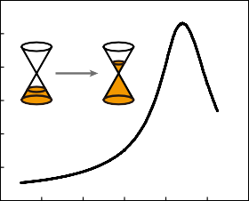

50 mK

8

*R*graphene (k▲)

6

4

2

0

–0.6 –0.4 –0.2 0 0.2 0.4 0.6

*V*int (V)

0

0 0.2 0.4 0.6

*T* (K)

### e

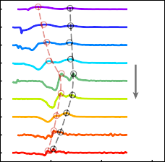

*T*F

*T*P

–200 V

*V*BG

200 V

8

–d2*R*LAO/STO/d*T* 2 (a.u.)

7

6

5

4

3

2

1

0.2

*T* (K)

0.1

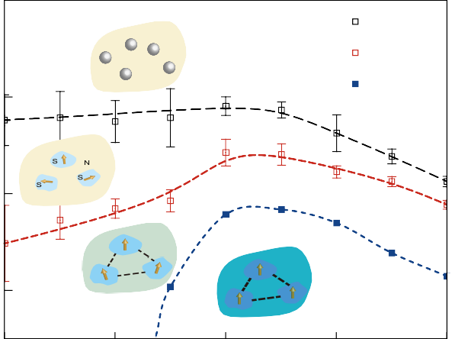

e

e

e Normal 2D electron gas

e

e

*T*P

*T*F *T*C

SC

puddles

Phase

fluctuations

2D superconductor

–200 –100 0 100 200

0

0 0.2 0.4 0.6

*T* (K)

*V*BG

(V)

**Fig. 1 | Device and intralayer transport characterizations. a**,**b**, Schematic

(**a**) and optical microscopy image (**b**) of the G­LAO/STO device. **c**, Resistance of graphene (*R*graphene) as a function of the interlayer gate voltage (*V*int) measured at 50 mK. **d**, Resistance of the LAO/STO interface (*R*LAO/STO) as a function of temperature (*T*) for back­gate voltage (*V*BG) varying from –200 to 200 V in

increments of 50 V. **e**, Second derivative of the *R*–*T* curves (–d2*R*LAO/STO/d*T*2) shown in **d**. For a fixed *V*BG, the two maxima are denoted as *T*F (red circles) and *T*P (black circles). The dashed lines indicate the traces of *T*F and *T*P as *V*BG varies. **f**, Low­

temperature *V*BG–*T* phase diagram of the LAO/STO interface obtained from **d** and

**e**. We define *T*C (blue squares) as the temperature at which the resistance drops to 1% of the normal­state resistance at *T* = 400 mK. *T*F (black hollow squares) and *T*P (red hollow squares) are the second­derivative maxima in **e** and the error bars

are evaluated by the full­width at half­maximum of the corresponding peaks. The dashed lines estimate the phase boundaries, and the schematic of the phases are depicted.

normal metal. Preliminary experiments based on metal–supercon­ ductor double films were conducted two decades ago17,18, and rather weak and uncontrolled drag responses were observed in the immedi­ ate vicinity of the SC transition. The estimated magnitude of PAR in a metal–superconductor system is down to the order of 10–3, and the mechanism remains unclear16–19.

Benefiting from fast­developing 2D materials science, sandwich structures combining graphene and other 2D electron systems have sparked renewed interest in studying physics dominated by interlayer Coulomb interactions9,10,25–27. The highly tunable transport properties of the component layers together with an ultrathin dielectric spacer ena­ ble us to investigate the drag effect in previously inaccessible regimes. In this work, we exploit a hybrid structure of graphene and LaAlO3 (LAO)/SrTiO3 (STO) heterointerface to simulate Coulomb­coupled normal conductor and superconductor in the ultimate 2D limit. We observe a giant and highly gate­tunable drag response in the vicinity of the SC transition of the LAO/STO interface. We attribute this drag phenomenon to a mechanism in which drag arises from the effective Coulomb coupling between the quantum fluctuations of the SC phases in the superconductor and charge density in the normal conductor.

A schematic of the hybrid device comprising graphene and LAO/ STO, denoted as G­LAO/STO, is shown in Fig. 1a. We used macroscale graphene (typical size of about 2 mm × 2 mm) grown via chemical

vapour deposition to avoid nanofabrication­induced degradation in the electronic performance of the LAO/STO interface (Fig. 1b; Methods provides the fabrication details). The pristine 2D superconductivity of the LAO/STO interface is well maintained in the final device, mani­ fested as the observation of a typical Berezinskii–Kosterlitz–Thouless transition28 (Extended Data Fig. 1 and Supplementary Section 1). Fur­ thermore, the interfacial superconductivity of LAO/STO can be readily tuned via a back­gate voltage (*V*BG) applied across the STO substrate (Fig. 1d), as demonstrated in previous studies29,30. The impact of *V*BG on the doping level of graphene is negligible (Extended Data Fig. 2), exhibiting the perfect shielding effect of the LAO/STO layer. On the other hand, both carrier type and density of the graphene layer can be tuned via the interlayer gate voltage (*V*int) utilizing LAO as the dielectric layer (Fig. 1c), with negligible impact on the electronic performance of the LAO/STO interface (Extended Data Fig. 3).

The resistance­to­temperature (*R*–*T*) curves of the LAO/STO interface exhibit two­step transitions between the high­temperature normal­metal phase and the low­temperature SC phase (Fig. 1d). This feature can be resolved from the second derivative of the *R*–*T* curves (Fig. 1e), where we assign two characteristic temperatures, *T*P and *T*F, to the peaks. The two­step SC transition has been reported in previous studies and understood in the context of electronic phase separa­ tion28,29. In fact, in addition to the transport characterizations, direct

### a b

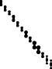

0.4

0.2 K

0

–0.4

–0.4 0 0.4

*I*drive (µA)



*I*drive

Graphene

2

0

–0.5 1

*R*LAO/STO (k▲)

*R*drag (▲)

*V*drag (µV)

*V*drag

*I*drag

LAO/STO

V

### c

*B*

1 T

3 T

0

–1

*R*drag (▲)

–2

1

0

–1

2

1

0

2.0

1.8

1.6

–1.0

–1.5

0

### d

100 mK

Normal

SC

Normal

0

*R*LAO/STO (k▲)

–1

*R*drag (▲)

–2

0.1

0.2

0

0.3 0.4 0.5

*T* (K)

2

1

*R*LAO/STO (k▲)

0

0 0.1 0.2 0.3 0.4 0.5

*T* (K)

**Fig. 2 | Interlayer drag resistances. a**, Schematic of the setup for drag measurements. Active current *I*drive is applied to the graphene layer, passive voltage drop *V*drag is measured at the LAO/STO interface and passive current is defined by *I*drag = –*V*drag/*R*LAO/STO. **b**–**d**, Results for zero *V*BG (Fig. 1a). Drag resistance

–4 –3 –2 –1 0 1 2 3 4

*B* (T)

(*R*drag = *V*drag/*I*drive) and *R*LAO/STO as functions of *T* in the absence of a magnetic field (**b**). The inset shows perfect linear dependence of *V*drag on *I*drive for |*I*drive | < 0.4 µA. *R*drag and *R*LAO/STO as functions of *T* for an in­plane magnetic field *B* = 1 T (top) and *B* = 3 T (bottom) (**c**). *R*drag and *R*LAO/STO as functions of in­plane *B* at *T* = 100 mK (**d**).

imaging measurements have demonstrated that 2D superconductiv­ ity at the LAO/STO interface is spatially inhomogeneous, manifested as the formation of quenched­disorder­induced SC puddles, with a typical length scale of micrometres31. The SC LAO/STO interface can be interpreted as a 2D Josephson junction ( JJ) array29,32,33, where the inter­puddle Josephson coupling plays an essential role in the forma­ tion of global phase coherence.

Within this scenario, the first resistance drop at *T*P can be explained as the onset of the Cooper pairing of localized electrons and thus the formation of SC puddles, and the second drop at *T*F cor­ responds to the onset of inter­puddle phase coherence impaired by thermal or quantum fluctuations. As shown in Fig. 1f, we can distin­ guish four phases of the LAO/STO interface in the temperature­gating phase diagram: the normal 2D electron gas state, the local SC puddle state, the phase­fluctuating state and the global­phase­coherent 2D SC state29. The three critical temperatures, namely, *T*P, *T*F and the SC transition temperature *T*C, are non­monotonic functions of *V*BG, and their maxima occur at nearly identical *V*BG, which corresponds to optimal doping.

For the drag measurements, we applied an active current (*I*drive) to the graphene layer, and measured the passive voltage drop (*V*drag) at the LAO/STO interface in an open circuit11,25,26 (Extended Data Figs. 4 and 5; Supplementary Section 2 provides a validity check). As shown in Fig. 2a, the moving carriers in the graphene layer could result in a pas­ sive current (*I*drag) at the LAO/STO interface via interlayer interactions, and the net charge accumulation at the two ends induces a voltage rectifying the passive current. In Fig. 2b, we show the linear dependence of *V*drag and *I*drive and plot the measured drag resistance (*R*drag = *V*drag/*I*drive) as a function of *T* for device #1, in which the LAO layer has a thickness of five unit cells (approximately 2 nm), together with the *R*–*T* curve of the LAO/STO interface for comparison purposes. A negative drag resist­ ance peak develops at *T* ≈ 195 mK, accompanying the SC transition of

the LAO/STO interface, whereas there is no detectable drag signal when the LAO/STO interface is either in the normal state or in the SC state.

We note that the negative sign of the drag resistance implies parallel *I*drag and *I*drive. These features (Fig. 2b) can be reproduced in other G­LAO/STO devices (Extended Data Fig. 6). Applying a moderate in­plane magnetic field (*B*) of 1 T substantially depresses the supercon­ ductivity of the LAO/STO interface, indicated by the broadening of the SC transition region and decrease in *T*C. Accordingly, the drag resist­ ance peak broadens and shifts to a lower temperature of *T* ≈ 160 mK (Fig. 2c). As the magnetic field is further increased to *B* = 3 T, the drag signal disappears along with a concomitant quenching of the LAO/STO interfacial superconductivity (Extended Data Fig. 7 shows the results under perpendicular fields). The correlation between drag response and SC transition of the LAO/STO interface is further evidenced by the field dependence of *R*drag (Fig. 2d), where detectable drag occurs only within the SC transition region.

The high tunability of the LAO/STO interfacial superconductivity enables us to investigate the SC­related drag effect in a wider param­ eter space. Figure 3a shows the phase diagram of *R*LAO/STO obtained by sweeping *V*BG at different *T* values. An SC dome with a maximum of *T*C ≈ 180 mK at *V*BG ≈ 27 V is evident, which is in agreement with previous studies29,30. Figure 3b shows the phase diagram of *R*drag as a function of *V*BG and *T*. Clearly, the regions where *R*drag is finite also constitute a dome­like shape surrounding the SC dome of the LAO/STO interface. The maximum *R*drag reaches up to about 2 Ω, which is much larger than those observed in systems consisting of normal­metal and conven­ tional SC films17,18. The inherent correlation between drag signals and LAO/STO interfacial superconductivity can also be seen by comparing the *B*–*V*BG phase diagrams of *R*LAO/STO and *R*drag (Fig. 3d,e, respectively). More importantly, when the extracted curves of *T*F and *T*C with respect to *V*BG are overlaid with the phase diagram of *R*drag (Fig. 3b), we find that the drag signal can be detected only when *T*C < *T* < *T*F in

### a

0.4

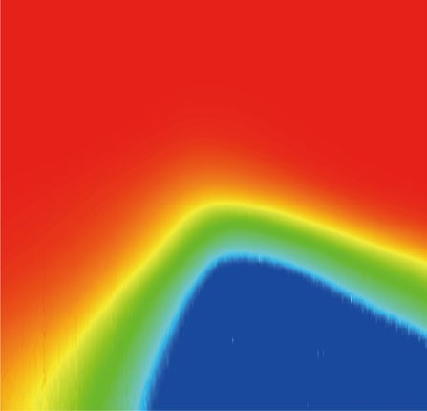

Normal

0 T

*T*F

Phase fluctuations

SC

*T*C

0.3

*T* (K)

0.2

0.1

*R*/*R*n

100



10–1

10–2

**b**

0.4

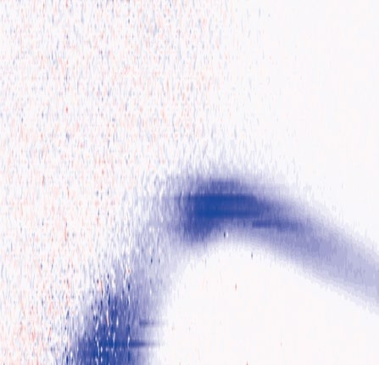

Normal

0 T

*T*F

SC

*T*C

0.3

*T* (K)

0.2

0.1

*R*drag (▲)

2



1

0

–1

–2

**c**

0.4

0.3

*T* (K)

0.2

0.1

*r*

10–1



10–2

10–3

–200 –100 0 100 200

*V*BG (V)

### d

*R*/*R*n

100



–200 –100 0 100 200

*V*BG (V)

1. *R*drag (▲)

–200 –100 0 100 200

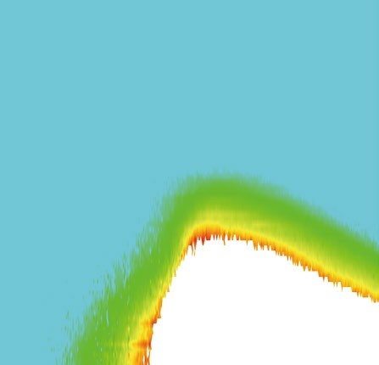

Normal

0 T

SC

*V*BG (V)

1. *r*

3 3

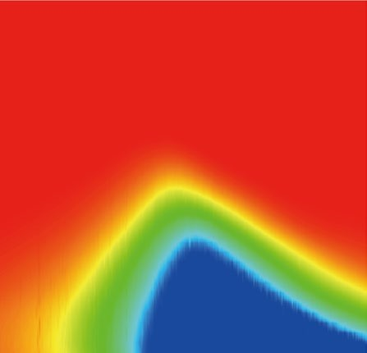

Normal

100 mK

SC

2 2

*B* (T)

*B* (T)

10–1

1 1

10–2

0 0

2 3

1

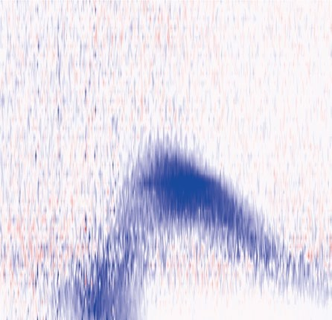

Normal

100 mK

SC

2

*B* (T)

0

–1 1

–2

0

|  |  |  |  |  |  |  |  |  |  |  |  |  |  |  |
| --- | --- | --- | --- | --- | --- | --- | --- | --- | --- | --- | --- | --- | --- | --- |
| –200 | –100 | 0 | 100 | 200 | –200 | –100 | 0 | 100 | 200 | –200 | –100 | 0 | 100 | 200 |
|  |  | *V*BG (V) |  |  |  |  | *V*BG (V) |  |  |  |  | *V*BG (V) |  |  |

10–1

10–2

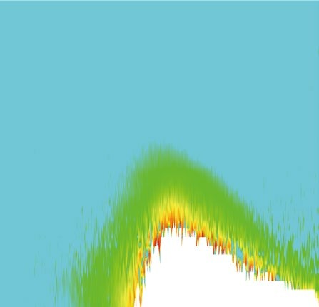

Normal

100 mK

SC

10–3

**Fig. 3 | Phase diagrams of the interlayer drag effect. a**–**c**, Normalized resistance of the LAO/STO interface (*R*LAO/STO/*R*n) (**a**), *R*drag (**b**) and dimensionless drag coefficient of PAR (*r* = –*R*drag/*R*LAO/STO) (**c**) as functions of *V*BG and *T* in the absence

of a magnetic field. *R*n is the normal­state resistance of the LAO/STO interface at

*T* = 400 mK. In **a** and **b**, *T*C (white dashed lines) is defined by the temperature at

which the resistance drops to 1% of the normal­state resistance at *T* = 400 mK. *T*F (black squares and dashed lines) and the error bars are evaluated by the full­width at half­maximum of the corresponding peaks. **d**–**f**, *R*LAO/STO/*R*n (**d**), *R*drag (**e**) and *r* (**f**) as functions of *V*BG and in­plane *B* at *T* = 100 mK.

the whole range of *V*BG. One can phenomenologically describe this non­monotonic temperature dependence of *R*drag as follows. In the nor­ mal region (*T* > *T*P), the undetectable drag signal is expected because the interlayer inelastic Coulomb scatterings between normal electrons are strongly suppressed at such low temperatures1,11,25. In the SC puddle region (*T*F < *T* < *T*P), the presence of incoherent Cooper pairs in the LAO/ STO interface does not substantially enhance the drag signal. Eventu­ ally, the drag effect is detectable only when the inter­puddle SC phase coherence is established for *T* < *T*F. Within the fully SC region (*T* < *T*C), the measured drag resistance is again negligible simply because there is no voltage drop across a superconductor.

To analyse the drag effect below *T*F, we consider the PAR, defined by the dimensionless coefficient *r* = *I*drag/*I*drive = −*R*drag/*R*LAO/STO (Supplemen­ tary Section 3 and Extended Data Fig. 8), as a function of *V*BG and *T*. Com­ pared with the drag resistance, the PAR eliminates the passive­layer resistance and manifests the intrinsic correlations between the two layers. As demonstrated in Fig. 3c, the PAR is positive and exhibits a dome­like shape for *T* < *T*F, similar to the drag resistance (Fig. 3b). How­ ever, the PAR is an increasing function of temperature, and becomes unmeasurable in the fully SC region of the LAO/STO interface where the absolute error approaches infinity18. Notably, the maximum value of PAR is *r* ≈ 0.3 occurring at *V*BG ≈ 20 V and *T* ≈ 170 mK, which is two orders of magnitude larger than that obtained in AlO*x*–Au/Ti hetero­ structures18. Strong and highly gate­tunable PAR signals are also clearly evident in the *V*BG–*B* diagram (Fig. 3f).

We clarify the drag mechanism between a normal conductor and a superconductor before analysing the PAR data. The low­energy physics of our hybrid device below the SC puddle temperature can be effec­ tively described by the model of 2D Dirac fermions coupling to a 2D JJ

array via Coulomb interactions. A detailed theoretical analysis can be found in Supplementary Section 5. The effective action of the system is composed of three parts, namely, *S* = *S*s + *S*n + *S*c. First, *S*s character­ izes the dynamics of the phase variables *φj*(*t*) of the s­wave SC puddles centred at the in­plane coordinates **R***j*. Here we introduce the Josephson energy between puddles as *E*J(*T*) = *E*J(0)(1 − (*T*/*T*P)2)exp(−*T*/*T*0), in which the factor 1 − (*T*/*T*P)2 arises from the superfluid density and *T*P is the puddle temperature32,34; the exponential factor exp(−*T*/*T*0) captures the Cooper­pair dephasing effect and *T*0 is proportional to the inverse inter­puddle distance35. Second, *S*n describes 2D Dirac fermions with Fermi velocity *v*F and charge density *ρ*(**r**, *t*) at the in­plane coordinate **r** and time *t*.

Most importantly, *S*c = −∑*j* ∫*uj*(**r**)*ρ*(**r**, *t*)*Vj*(*t*)d2**r**d*t* describes the non­local electrostatic interaction between the fermion charge den­ sity at position **r** and electric potential at the *j*th SC puddle, denoted by *Vj*(*t*) via dimensionless potential *uj*(**r**) = (*a*2*d*/2π)((**r** − **R***j*)2 + *d*2)−3/2, where *d* is the interlayer distance and *a*2 is the SC puddle area. We note that *uj*(**r**) is positive definite and analogous to the long­range Fröhlich electron–phonon couplings in polaron physics36. Via the a.c. Joseph­ son relation *Vj*(*t*) = −(*ħ*/2*q)*∂*tφj*(*t*), where *q* is the carrier charge of the LAO/STO interface (*q* < 0 for electrons and *q* > 0 for holes), one can readily realize that the coupling action *S*c, in fact, describes the interac­ tions between the SC phases and graphene electrons. As depicted in Fig. 4a, the evolutions of the SC phases generate time­dependent electric potentials in graphene and thus charge density fluctuations, and reciprocally, graphene charge density fluctuations could stimulate Cooper­pair tunnellings in the JJ array and thus SC phase variations. This type of interaction is intrinsically quantum and electrodynamical owning to the Josephson effect: it is absent if the system is composed

### a

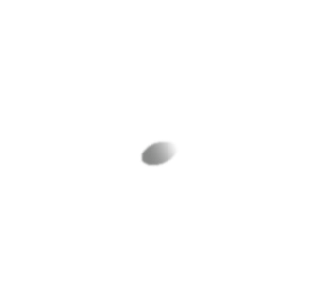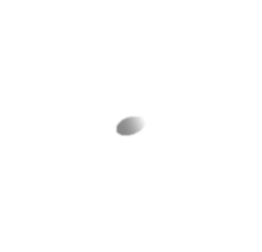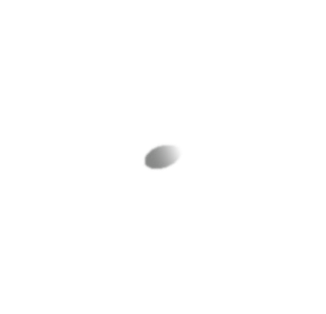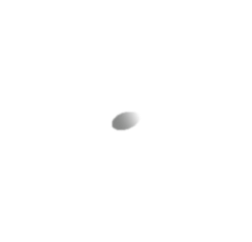

**b**

Graphene

e

e

e

*I*

*N*

e

e

LAO/STO

N

S

array

*V*drag

**d**

*r*

104

0.10

*r*

10–1

100

*V*BG = 0 V

0.05

*V*BG (V)

–100

–50

0

50

100

150

200

10–4

10–4

0.15 0.20 0.25

*T* (K)

0 0.1 0.2

*T* (K)

0

*φN*–2

*I*drive

Normal conductor

*I*3

*φ*3

**c**

*I*1

*I*2

*I*1

*I*1 + *I*2

JJ

–

*φ*1

*φ*2

0.10

0.05

*r*

-2 *IN*-1 *IN*

*φN*

*φN*–1

*IN* + *IN*–1 *IN*

+

### e

106

103

*r*

*r*0

107

104

*E*J (0) (K)

0

0 0.1

0.2 0.3 0.4

*T* (K)

0 0.1

0.2 0.3 0.4 0.5

*T* (K)

100

–100 0 100 200

*V*BG (V)

101

**Fig. 4 | JC drag effect below *T*P. a**, Schematic of the long­range couplings between the phases of order parameters of the SC puddles at the LAO/STO interface and graphene electrons mediated by Coulomb interactions below *T*P. Charge­density temporal fluctuations in graphene accelerate the phase velocity of an SC puddle at the LAO/STO interface, and conversely, the phase velocity of an SC puddle generates an electric potential acting on graphene electrons. **b**, Schematic of the JC drag between a JJ array and a normal conductor in one­ dimensional geometry. Active current *I*G is applied in the normal conductor

and an induced current *Ij*(*t*) flows in or out of the *j*th puddle depending on the

location. At each junction, the passive bias current is parallel to the active current and the rectification voltage leads to a positive PAR. **c**, Drag coefficient of PAR (*r*) as a function of *T* for *V*BG = 0 V and *B* = 0 T. We use the functions *r*(*T*) = *r*0(1 – (*T*/*T*\*)2) (orange dashed line) and *r*(*T*) = *r*0(1 – (*T*/*T*P)2)exp(–*T*/*T*0) (black dashed line) to

fit the data. The inset shows the semi­log plots in the low­temperature region. **d**, *r* as a function of *T* for various *V*BG values. We fit the data using the function *r*(*T*) = *r*0(1 – (*T*/*T*P)2)exp(–*T*/*T*0). The inset shows the semi­log plots. **e**, Zero­ temperature drag coefficient *r*0 and Josephson energy *E*J(0) as a function of *V*BG extracted from the fitting results in **d**.

of charge­neutral quasiparticles, in thermal equilibrium or in the clas­ sical limit *ħ* → 0, and can be substantially enhanced for high­frequency fluctuations.

This drag effect, which we call the Josephson–Coulomb ( JC) drag effect, manifests in the coupling action. The charge density fluctuations in graphene induce an effective bias current *Ij*(*t*) flowing out of the *j*th SC puddle. The electric potentials in the JJ array induce electric potentials *V*(**r**, *t*) in graphene. In the semiclassical limit, one has *Ij*(*t*) = ∫**j**(**r**, *t*)·∇*uj*(**r**) d2**r** and *V*(**r**, *t*) = ∑*juj*(**r**)*Vj*(*t*), where **j**(**r**, *t*) is the 2D charge current density in graphene. Furthermore, in the globally SC region of the JJ array, the interlayer coupling can be renormalized by the gapless Bogoliubov– Anderson–Goldstone mode37–39 via the vertex corrections, meaning *uj*(**r**) → *γuj*(**r**). We have obtained the enhancement factor *γ*(*ρ*, *T*) ≈ *E*J(*T*)/ (*ħv*F)2*χ*0(*ρ*, *T*), where *χ*0(*ρ*, *T*) is the static and uniform Lindhard function of graphene electrons (Supplementary Section 5).

In Fig. 4b, we show a schematic of the JC drag processes between a one­dimensional JJ array and a graphene strip along the *x* direction in the region 0 < *x* < *L*. A uniform active current *I*G in the graphene strip induces the bias currents *Ij* = *I*G(*uj*(*L*) – *uj*(0)), for which the sign depends on that of the effective potential *uj*(*x*) as well as the location of the puddle (Supplementary Section 5). As a result, at each junction, the induced current is parallel to the active one, obtained by Kirchoff’s law; therefore, a rectification voltage develops and leads to a positive PAR. Further, assuming *N* identical JJ arrays in parallel, we estimate the PAR as *r*(*ρ*, *T*) ≈ *aNE*J(*T*)/2π*d*(*ħv*F)2*χ*0(*ρ*, *T*); therefore, it can be substan­ tially enhanced by increasing *N*. In the degenerate (non­degenerate) region of graphene *T* ≪ |*E*F|(*T* ≫ |*E*F|) (ref. 40), where *E*F is the Fermi energy with respect to charge neutrality, the order of magnitude of PAR is given by *r* ~ *aNE*J(*T*)/*d*max(|*E*F|, *T*). In practise, the SC puddles form a complex 2D network rather than independent one­dimensional

arrays. Nevertheless, this only influences the quantitative estimation of effective channel number *N*.

According to the PAR, the JC drag exhibits properties distinct from the conventional Coulomb drag phenomena, especially those based on the momentum transfer mechanism11 (Supplementary Section 4). First, the sign of PAR is positive definite, determined by that of the effective coupling *uj*(**r**) and independent of the carrier types of both layers. Second, at constant temperature, the PAR is maximized as the graphene layer approaching charge neutrality since the Coulomb interaction is less screened. These conclusions coincide well with our experimental result (Extended Data Fig. 9), where the drag resistance is almost particle–hole symmetric as the graphene layer tuned across the Dirac point. The maximum value of the drag resistance around the Dirac point should be limited by the charge puddles in graphene, attributed to the density dependence of the dielectricity of graphene electrons. Notably, for a fixed graphene carrier density, the PAR reaches its maximum at zero temperature instead of vanishing since the Joseph­ son energy *E*J(*T*) increases with decreasing temperature. In addition, the amplitude of PAR is limited only by the experimental parameters and can diverge as *N*/max(|*E*F|, *T*) when max(|*E*F|, *T*) → 0 or *N* → ∞. In our experiment, the graphene layer is deep in the degenerate region for *T* < *T*P, and the temperature dependence of PAR should arise from the Josephson energy; therefore, *r* ~ *r*0(1 − (*T*/*T*P)2)exp(−*T*/*T*0), where *r*0 ~ *aNE*J(0)/*d*|*E*F|. The experiment and theory show good consistency with each other (Fig. 4c,d) for various gate voltages (Extended Data Fig. 10 shows the results for another device). In contrast, neglecting the exponential factor, we obtain regression curves that substantially deviate from the experimental data (Fig. 4c). This also evidences the JJ­array superconductivity of the LAO/STO interface along with the

two­step transition (Fig. 1d,e).

The PAR that is not measurable below *T*C can now be extrapolated down to zero temperature. As shown in Fig. 4e, the extracted *r*0 exhibits non­monotonic back­gate dependence and it is as large as 105 for the optimal gate value. For closed passive circuits, this means that applying an active current in graphene can induce an astonishing passive current 105 times larger in the superconductor layer in close proximity. Along with *r*0, we show the back­gate dependence of the zero­temperature Josephson energy *E*J(0) (Fig. 4e and Supplementary Section 6). We find that around optimal gating, the giant *r*0 is attributed to the fact that *E*J(0) is obviously larger than the Fermi energy of the graphene layer; away from optimal gating, *E*J(0) and thus *r*0 are substantially suppressed.

This JC drag mechanism reveals the unique role of the Josephson effect, which is a universal macroscopic quantum phenomenon in non­uniform superconductors, in shaping the interlayer multiparti­ cle interactions. This JC drag should belong to the broad spectrum of energy drag41, since, at the particle–hole symmetric point or at zero temperature, the drag effect is maximized instead of vanishing, in contrast to the conventional momentum drag11. The JC drag effect is inherently in non­equilibrium because a non­vanishing effective interlayer coupling requires quantum fluctuations in SC phases in the superconductor. Such an effect should be much weaker for uniform superconductors due to substantially suppressed quantum fluctua­ tions of the SC phases. The quantum­fluctuation­induced static inter­ actions like the Casimir effect are commonly attributed to zero­point motions of systems in equilibrium and manifested as thermodynamical variables42. In addition, the interaction between the SC phases in the superconductor and electrons in the normal conductor that we discov­ ered here serves as a prototype of the quantum­fluctuation­induced dynamical forces that can be detected only as the system is driven out of equilibrium.

From an engineering perspective, our JC drag device works as a current (voltage) transformer when graphene (LAO/STO interface) is active. Moreover, it may provide an alternative way to synchronize the terahertz radiators based on large JJ arrays43,44, since the bias cur­ rent distribution in the JJ arrays can be directly controlled by that in a closely proximitized graphene layer45. Therefore, we anticipate that our findings will promote further investigation of hybrid interlayer coupling via adopting other 2D systems possessing various quan­ tum phases46,47. The inherent quantum fluctuations tend to produce many­body effects, which may further find applications in highly inte­ grated modern electronics.

# Online content

Any methods, additional references, Nature Portfolio reporting sum­ maries, source data, extended data, supplementary information, acknowledgements, peer review information; details of author con­ tributions and competing interests; and statements of data and code availability are available at [https://doi.org/10.1038/s41567­022­01902­7](https://doi.org/10.1038/s41567-022-01902-7).

# References

1. Gramila, T. J., Eisenstein, J. P., MacDonald, A. H., Pfeiffer, L. N. & West, K. W. Mutual friction between parallel two-dimensional electron systems. *Phys. Rev. Lett.* **66**, 1216–1219 (1991).
2. Eisenstein, J. P. New transport phenomena in coupled quantum wells. *Superlattices Microstruct.* **12**, 107–114 (1992).
3. Price, A., Savchenko, A., Narozhny, B., Allison, G. & Ritchie, D. Giant fluctuations of Coulomb drag in a bilayer system. *Science* **316**, 99–102 (2007).
4. Yamamoto, M., Stopa, M., Tokura, Y., Hirayama, Y. & Tarucha, S. Negative Coulomb drag in a one-dimensional wire. *Science* **313**, 204–207 (2006).
5. Laroche, D., Gervais, G., Lilly, M. & Reno, J. 1D-1D Coulomb drag signature of a Luttinger liquid. *Science* **343**, 631–634 (2014).
6. Eisenstein, J. P. & MacDonald, A. H. Bose–Einstein condensation of excitons in bilayer electron systems. *Nature* **432**, 691–694 (2004).
7. Su, J.-J. & MacDonald, A. H. How to make a bilayer exciton condensate flow. *Nat. Phys.* **4**, 799–802 (2008).
8. Nandi, D., Finck, A. D. K., Eisenstein, J. P., Pfeiffer, L. N. & West, K.

W. Exciton condensation and perfect Coulomb drag. *Nature* **488**, 481–484 (2012).

1. Liu, X., Watanabe, K., Taniguchi, T., Halperin, B. I. & Kim, P. Quantum Hall drag of exciton condensate in graphene. *Nat. Phys.* **13**, 746–750 (2017).
2. Li, J., Taniguchi, T., Watanabe, K., Hone, J. & Dean, C. Excitonic superfluid phase in double bilayer graphene. *Nat. Phys.* **13**, 751–755 (2017).
3. Narozhny, B. & Levchenko, A. Coulomb drag. *Rev. Mod. Phys.* **88**, 025003 (2016).
4. Du, L. et al. Coulomb drag in topological wires separated by an air gap. *Nat. Electron.* **4**, 573–578 (2021).
5. Giaever, I. Magnetic coupling between two adjacent type-II superconductors. *Phys. Rev. Lett.* **15**, 825–827 (1965).
6. Giaever, I. Flux pinning and flux-flow resistivity in magnetically coupled superconducting films. *Phys. Rev. Lett.* **16**, 460–462 (1966).
7. Averin, D. V., Korotkov, A. N. & Nazarov, Y. V. Transport of electron-hole pairs in arrays of small tunnel junctions. *Phys. Rev.* *Lett.* **66**, 2818–2821 (1991).
8. Duan, J.-M. & Yip, S. Supercurrent drag via the Coulomb interaction. *Phys. Rev. Lett.* **70**, 3647–3650 (1993).
9. Giordano, N. & Monnier, J. D. Cross-talk effects in

superconductor-insulator-normal-metal trilayers. *Phys. Rev. B* **50**, 9363–9368 (1994).

1. Huang, X., Bazàn, G. & Bernstein, G. H. Observation of supercurrent drag between normal metal and superconducting films. *Phys. Rev. Lett.* **74**, 4051–4054 (1995).
2. Shimshoni, E. Role of vortices in the mutual coupling of superconducting and normal-metal films. *Phys. Rev. B* **51**, 9415–9418 (1995).
3. Shimada, H. & Delsing, P. Current mirror effect and correlated Cooper-pair transport in coupled arrays of small Josephson junctions. *Phys. Rev. Lett.* **85**, 3253–3256 (2000).
4. Zou, Y., Refael, G. & Yoon, J. Investigating the superconductor-insulator transition in thin films using drag

resistance: theoretical analysis of a proposed experiment. *Phys.* *Rev. B* **80**, 180503 (2009).

1. Levchenko, A. & Norman, M. R. Proposed Giaever transformer to probe the pseudogap phase of cuprates. *Phys. Rev. B* **83**, 100506 (2011).
2. Andreev, A. & Bashkin, E. Three-velocity hydrodynamics of superfluid solutions. *Sov. Phys. JETP* **42**, 164–167 (1976).
3. Alpar, M., Langer, S. A. & Sauls, J. Rapid postglitch spin-up of the superfluid core in pulsars. *Astrophys. J.* **282**, 533–541 (1984).
4. Kim, S. et al. Coulomb drag of massless fermions in graphene.

*Phys. Rev. B* **83**, 161401 (2011).

1. Gorbachev, R. V. et al. Strong Coulomb drag and broken symmetry in double-layer graphene. *Nat. Phys.* **8**, 896–901 (2012).
2. Gamucci, A. et al. Anomalous low-temperature Coulomb drag in graphene-GaAs heterostructures. *Nat. Commun.* **5**, 5824 (2014).
3. Reyren, N. et al. Superconducting interfaces between insulating oxides. *Science* **317**, 1196–1199 (2007).
4. Chen, Z. et al. Carrier density and disorder tuned superconductor-metal transition in a two-dimensional electron system. *Nat. Commun.* **9**, 4008 (2018).
5. Caviglia, A. et al. Electric field control of the LaAlO3/SrTiO3 interface ground state. *Nature* **456**, 624–627 (2008).
6. Bert, J. A. et al. Direct imaging of the coexistence of ferromagnetism and superconductivity at the LaAlO3/SrTiO3 interface. *Nat. Phys.* **7**, 767–771 (2011).
7. Manca, N. et al. Bimodal phase diagram of the superfluid density in LaAlO3/SrTiO3 revealed by an interfacial waveguide resonator. *Phys. Rev. Lett.* **122**, 036801 (2019).
8. Hurand, S. et al. Josephson-like dynamics of the superconducting LaAlO3/SrTiO3 interface. *Phys. Rev. B* **99**, 104515 (2019).
9. Prozorov, R. & Giannetta, R. W. Magnetic penetration depth in unconventional superconductors. *Supercond. Sci. Technol.* **19**, R41 (2006).
10. Kapitulnik, A., Kivelson, S. A. & Spivak, B. Colloquium: anomalous metals: failed superconductors. *Rev. Mod. Phys.* **91**, 011002 (2019).
11. Alexandrov, A. S. & Kornilovitch, P. E. Mobile small polaron. *Phys.* *Rev. Lett.* **82**, 807–810 (1999).
12. Bogoljubov, N. N., Tolmachov, V. V. & Širkov, D. V. A new method in the theory of superconductivity. *Fortschr. Phys.* **6**, 605–682 (1958).
13. Anderson, P. W. Coherent excited states in the theory of superconductivity: gauge invariance and the Meissner effect. *Phys. Rev.* **110**, 827–835 (1958).
14. Goldstone, J. Field theories with superconductor solutions. *Nuovo* *Cim.* **19**, 154–164 (1961).
15. Ramezanali, M. R., Vazifeh, M. M., Asgari, R., Polini, M. & MacDonald, A. H. Finite-temperature screening and the specific heat of doped graphene sheets. *J. Phys.* **42**, 214015 (2009).
16. Berdanier, W., Scaffidi, T. & Moore, J. E. Energy drag in

particle-hole symmetric systems as quantum quench. *Phys. Rev. Lett.* **123**, 246603 (2019).

1. Casimir, H. B. G. On the attraction between two perfectly conducting plates. *Proc. Kon. Ned. Akad. Wet.* **51**, 793–795 (1948).
2. Han, S., Bi, B., Zhang, W. & Lukens, J. E. Demonstration of Josephson effect submillimeter wave sources with increased power. *Appl. Phys. Lett.* **64**, 1424–1426 (1994).
3. Barbara, P., Cawthorne, A. B., Shitov, S. V. & Lobb, C. J. Stimulated emission and amplification in Josephson junction arrays. *Phys.* *Rev. Lett.* **82**, 1963–1966 (1999).
4. Galin, M. A. et al. Direct visualization of phase-locking of large Josephson junction arrays by surface electromagnetic waves. *Phys. Rev. Appl.* **14**, 024051 (2020).
5. Saito, Y., Nojima, T. & Iwasa, Y. Highly crystalline 2D superconductors. *Nat. Rev. Mater.* **2**, 16094 (2017).
6. Gong, C. & Zhang, X. Two-dimensional magnetic crystals and emergent heterostructure devices. *Science* **363**, eaav4450 (2019).

**Publisher’s note** Springer Nature remains neutral with regard to jurisdictional claims in published maps and institutional affiliations.

Springer Nature or its licensor (e.g. a society or other partner) holds exclusive rights to this article under a publishing agreement with the author(s) or other rightsholder(s); author self-archiving of the accepted manuscript version of this article is solely governed by the terms of such publishing agreement and applicable law.

© The Author(s), under exclusive licence to Springer Nature Limited 2023

# Methods

#### Device fabrication

LAO/STO heterostructures (typical in­plane size, 5 mm × 5 mm) were fabricated using pulsed laser deposition following those described in our previous study48. The ultraflat surface and good interfacial conductivity were verified before the following procedures. Monolayer graphene sheets were grown on Cu foils by chemical vapour deposition49 and then directly transferred onto the LAO/STO surface, as previously reported50. For the transport measurements, Al (Au) wires were connected to the LAO/STO interface (graphene layer) using ultrasonic welding (silver con­ ductive paint). Ti/Au contacts with a thickness of 5/50 nm were fabricated on the back side of the STO substrates to apply the back­gate voltage.

#### Electronic transport measurements

The electronic transport measurements were performed in an Oxford Instruments Triton dilution refrigerator. During the drag measure­ ments, direct current (d.c.) mode was adopted to avoid the possible influence of capacitive reactance in alternating current (a.c.) measure­ ments26. Keithley 6220/6221 and 2182A instruments were employed to supply the currents in the active layer and measure the voltage drops in the passive layer, respectively. To eliminate the voltage background of the 2182A instrument, the current was applied using a bipolar mode, and the voltage was obtained by taking the average of the measured voltages at positive and negative currents.

# Data availability

Source data are provided with this paper. All other data that support the plots within this paper and other findings of this study are available from the corresponding authors on reasonable request.

# References

1. Liang, H. et al. Nonmonotonically tunable Rashba spin-orbit coupling by multiple-band filling control in SrTiO3-based interfacial *d*-electron gases. *Phys. Rev. B* **92**, 075309 (2015).
2. Li, X. et al. Large-area synthesis of high-quality and uniform graphene films on copper foils. *Science* **324**, 1312–1314 (2009).
3. Cheng, L. et al. Photoconductivity of graphene in proximity to LaAlO3/SrTiO3 heterostructures: phenomenon and photosensor applications. *Phys. Rev. Appl.* **6**, 014005 (2016).

# Acknowledgements

We thank F. Wu for helpful discussions. R.T., L.L., X.F., L.G., L.Z., Y.Y., Z.Z. and C.Z. were supported by the National Natural

Science Foundation of China (grant nos. 92165201, 11804326, 11974324), the Innovation Program for Quantum Science and Technology (grant no. 2021ZD0302800), the CAS Project for Young Scientists in Basic Research (grant no. YSBR-046), the Strategic Priority Research Program of Chinese Academy of Sciences (grant no. XDC07010000), the Anhui Initiative in Quantum Information Technologies (grant no. AHY170000), Hefei Science Center CAS (grant no. 2020HSC-UE014) and the Fundamental Research Funds for the Central Universities (grant no. WK3510000013). L.L. was also supported by USTC Tang Scholar. H.-Y.X. was supported by the National Natural Science Foundation of China (grant no. 12074039). Part of this work was carried out at the Center for Micro- and Nanoscale Research and Fabrication, University of Science and Technology of China.

# Author contributions

C.Z. and L.L. designed and supervised the work. R.T. and L.L. performed the experiments with assistance from X.F., L.G., L.Z. and

Y.Y. H.-Y.X. conceived the theoretical model. L.L., R.T., H.-Y.X. and C.Z. analysed the data and wrote the manuscript. Z.Z. contributed to data interpretation and presentation. All authors contributed to the scientific discussion and manuscript revisions.

# Competing interests

The authors declare no competing interests.

# Additional information

**Extended data** is available for this paper at <https://doi.org/10.1038/s41567-022-01902-7>.

**Supplementary information** The online version contains supplementary material available at <https://doi.org/10.1038/s41567-022-01902-7>.

**Correspondence and requests for materials** should be addressed to Lin Li, Hong-Yi Xie or Changgan Zeng.

**Peer review information** *Nature Physics* thanks Dimitrie Culcer, James Williams and the other, anonymous, reviewer(s) for their contribution to the peer review of this work.

**Reprints and permissions information** is available at [www.nature.com/reprints](http://www.nature.com/reprints).

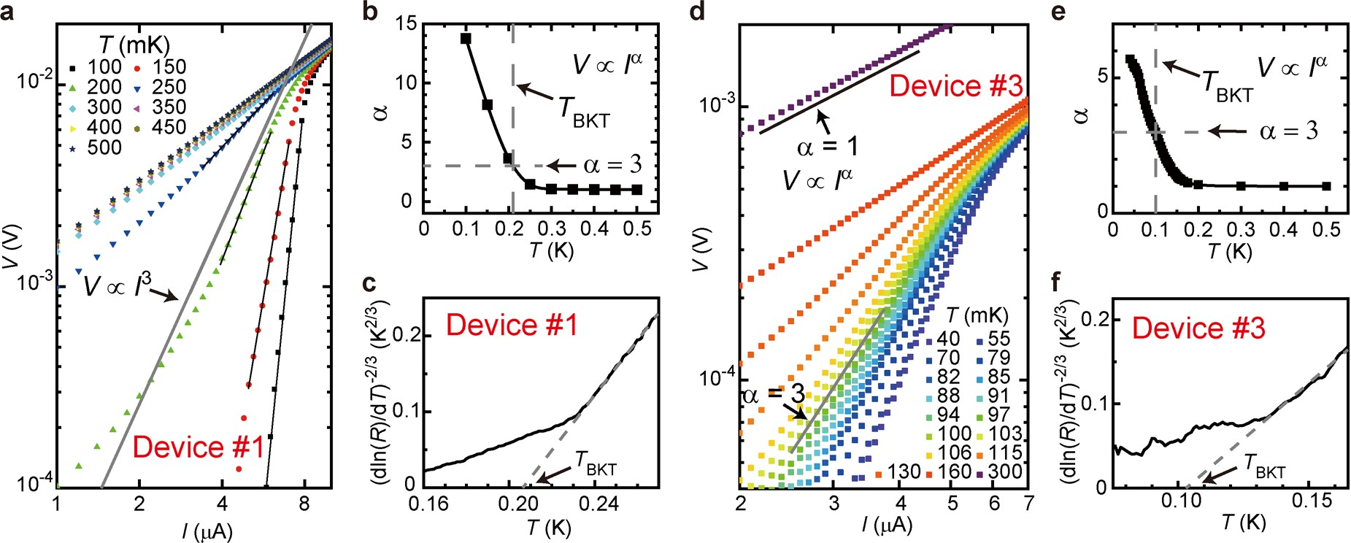

**Extended Data Fig. 1 | Berezinskii-Kosterlitz-Thouless transition of LAO/ STO interface in the final G-LAO/STO Devices. a**,**d**, The *V*­*I* curves of the LAO/

STO interface plotted on a semi­log scale for Devices #1 and #3, respectively. In **a**,

the black lines are *V* ∝ *I*α fits of the data in the transition region, and the gray line corresponds to the *V* ∝ *I*3 dependence. In **d**, the black and gray lines correspond

respectively to *V* ∝ *I* and *V* ∝ *I*3 dependencies. **b**,**e**, *T*­dependence of the exponent α, as deduced from the fits shown in **a** and **d**, respectively. **c**,**f**, *R*­*T* curves of

the LAO/STO interface plotted on a [dln(*R*)/d*T*]­2/3 scale for Devices #1 and #3, respectively.

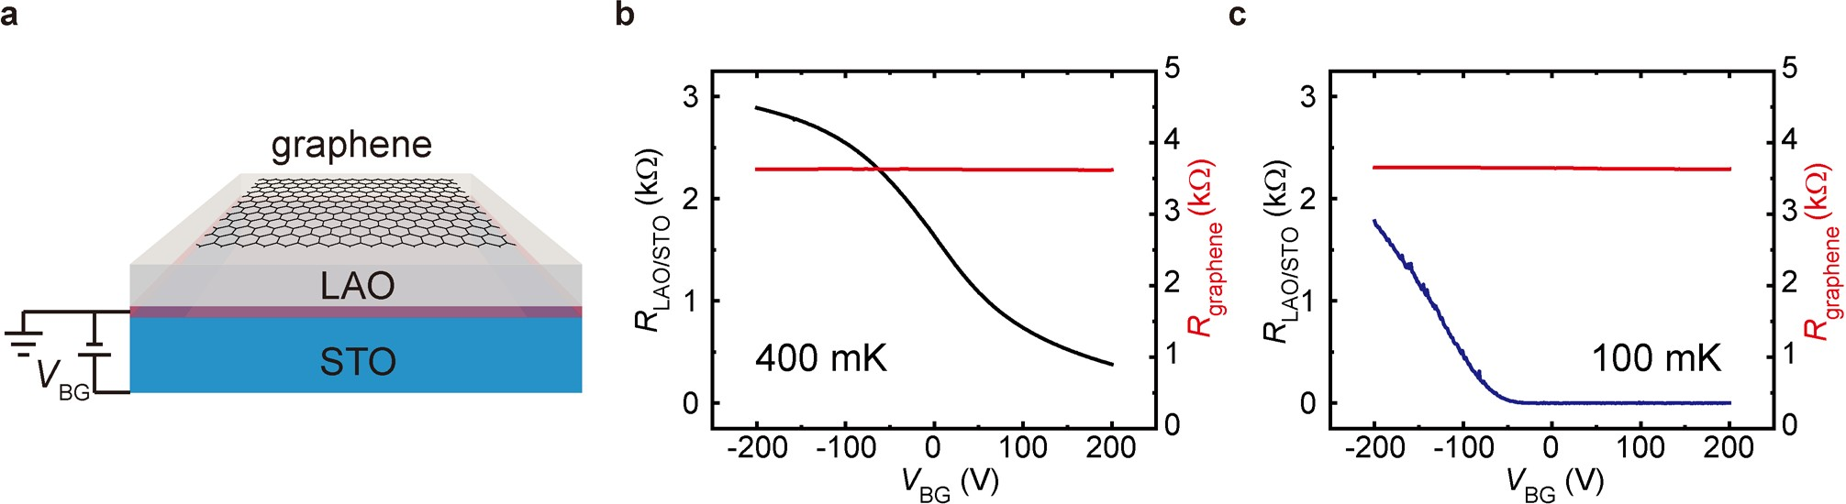

**Extended Data Fig. 2 | Negligible impact of the back-gate voltage on the doping level of graphene. a**, Schematic illustration of the back­gate voltage (*V*BG) tuning.

**b**,**c**, *R*LAO/STO and *R*graphene as functions of *V*BG measured at 400 mK and 100 mK, respectively.

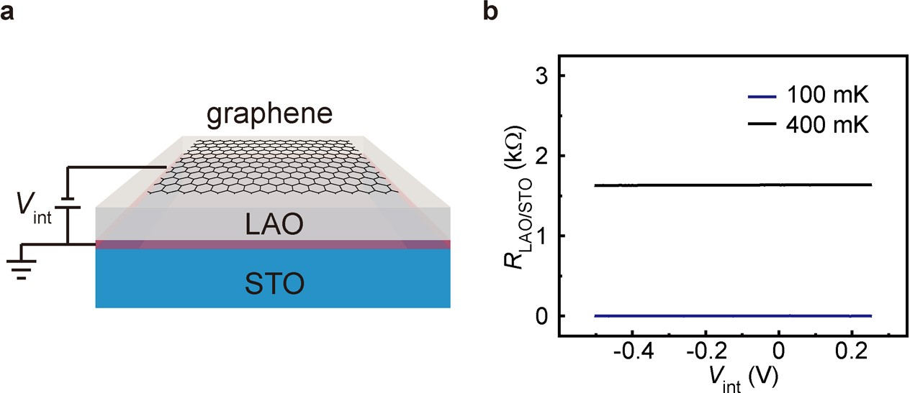

**Extended Data Fig. 3 | Negligible impact of the interlayer-gate voltage on the electronic performance of LAO/STO interface. a**, Schematic illustration of the interlayer­gate voltage (*V*int) tuning. **b**, *R*LAO/STO as a function of *V*int measured at 100 mK and 400 mK. In contrast to graphene (Fig. 1c in the main text), the impact

of *V*int on the electronic performance of LAO/STO interface is negligible. This is due to the fact that the typical carrier density of the LAO/STO interface is orders of magnitude higher than that of the graphene layer near the Dirac point.

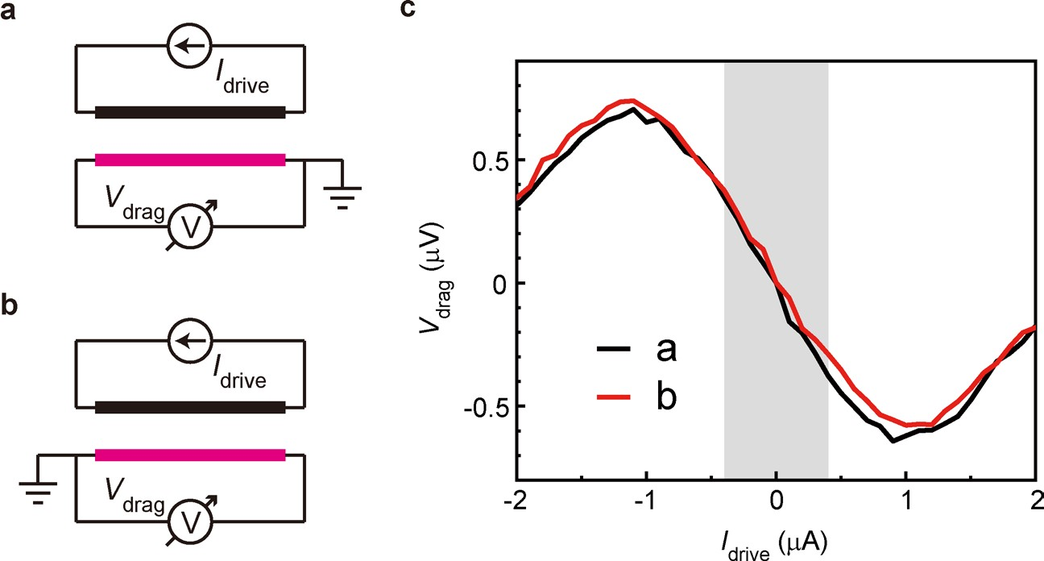

**Extended Data Fig. 4 | Exclusion of the impact of interlayer leakage/tunneling on the observed drag signal. a**,**b**, Schematic diagrams of the drag set­ups where the grounded point at the LAO/STO interface is switched. **c**, Comparison of *V*drag­*I*drive curves for two different set­ups measured at *T* = 200 mK and *V*BG = 0 V.

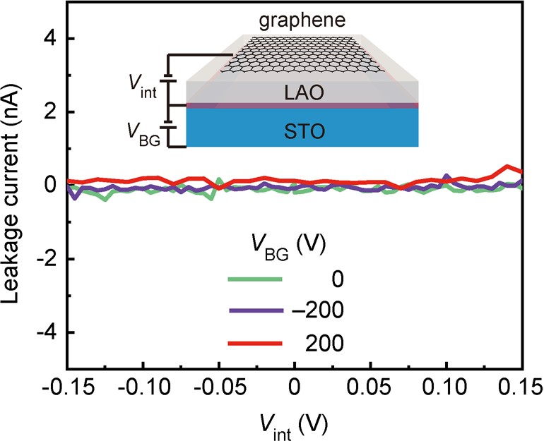

**Extended Data Fig. 5 | Negligible interlayer leakage.** Interlayer leakage current as a function of *V*int for different *V*BG.

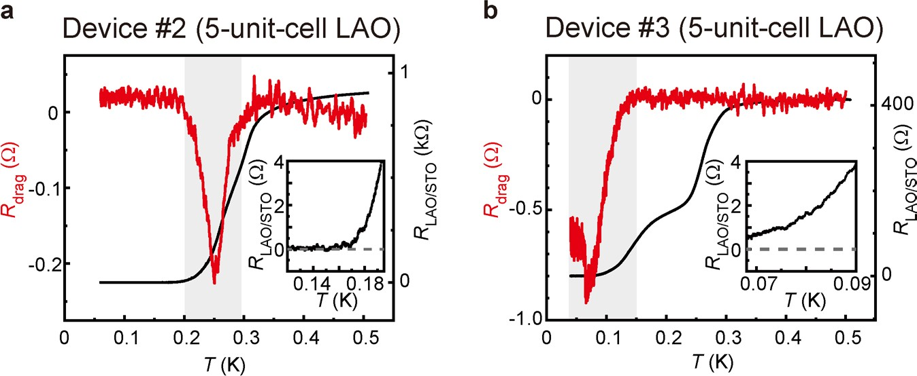

**Extended Data Fig. 6 | Drag resistances in different G-LAO-STO devices. a**,**b**, *R*drag and *R*LAO/STO as functions of *T* for Devices #2 and #3, respectively. Insets: enlarged­views of the *R*LAO/STO vs *T* curves. For Device #3, non­zero *R*drag is obtained

even at the lowest measuring temperature, which is consistent with the fact that the LAO/STO interface acting as the drag layer does not enter into the fully SC state.

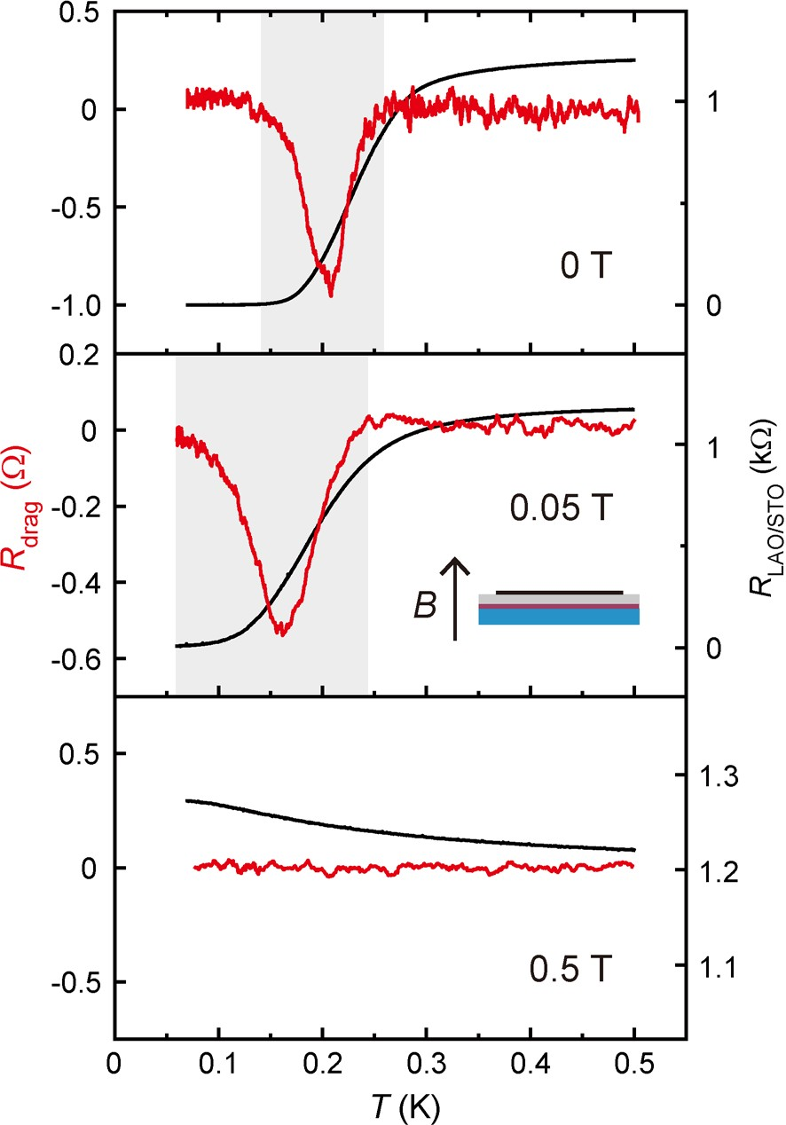

**Extended Data Fig. 7 | Evolution of drag effect under magnetic field applied perpendicular to the interfacial plane of LAO/STO.** From top to bottom: *R*drag and

*R*LAO/STO as functions of *T* measured under 0 T, 0.05 T and 0.5 T magnetic field, respectively.

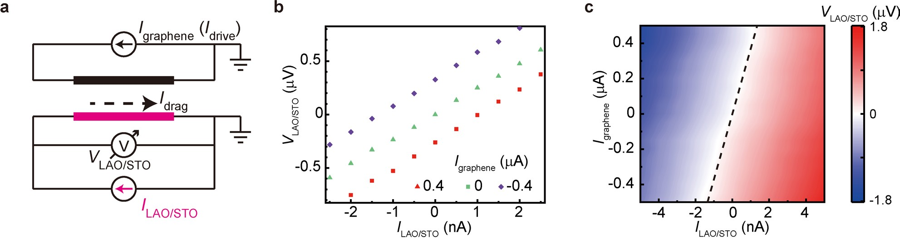

**Extended Data Fig. 8 | Counter-current measurements. a**, Schematic illustration of the set­up for the counter­current measurement. **b**, *V*LAO/STO as a function of *I*LAO/STO

measured with varying *I*graphene (*I*drive). The measurements were conducted at *T* = 200 mK and *V*BG = 0 V in Device #1. **c**, *V*LAO/STO as a function of *I*LAO/STO and *I*graphene (*I*drive).

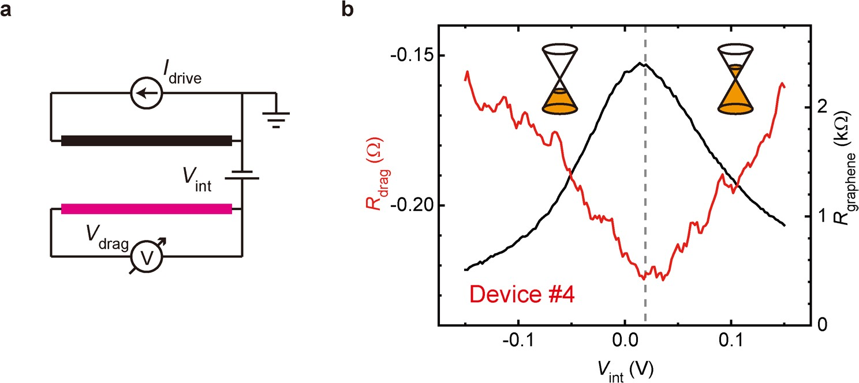

**Extended Data Fig. 9 | Evolution of drag resistance with the doping level of graphene. a**, Schematic illustration for the drag set­up, where the carrier density/polarity of graphene can be readily tuned using the interlayer­gate

voltage (*V*int). **b**, *R*drag and *R*graphene as functions of *V*int. The measurements were conducted at *T* = 40 mK and *V*BG = 0 V in a G­LAO/STO device with 14­unit­cell LAO (Device #4).

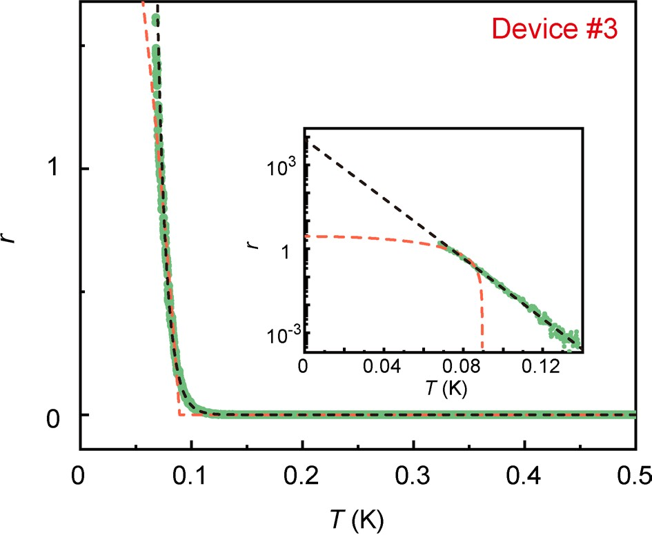

**Extended Data Fig. 10 | Fits of the drag coefficient of PAR (*r* = -*R*drag/*R*LAO/STO) for Device #3.** *r* as a function of *T* and the corresponding fitting curves obtained using equations *r*(*T*) = *r*0[1­(*T*/*T*\*)2] (orange dashed line) and *r*(*T*) = *r*0[1­(*T*/*T*P)2]exp(­*T*/*T*0) (black dashed line). Inset: The corresponding semi­log plots. The experiments were conducted at *V*BG = 0 V. Via the fitting, the ratio *r* at the zero­temperature limit is estimated to be around 0.8×104.